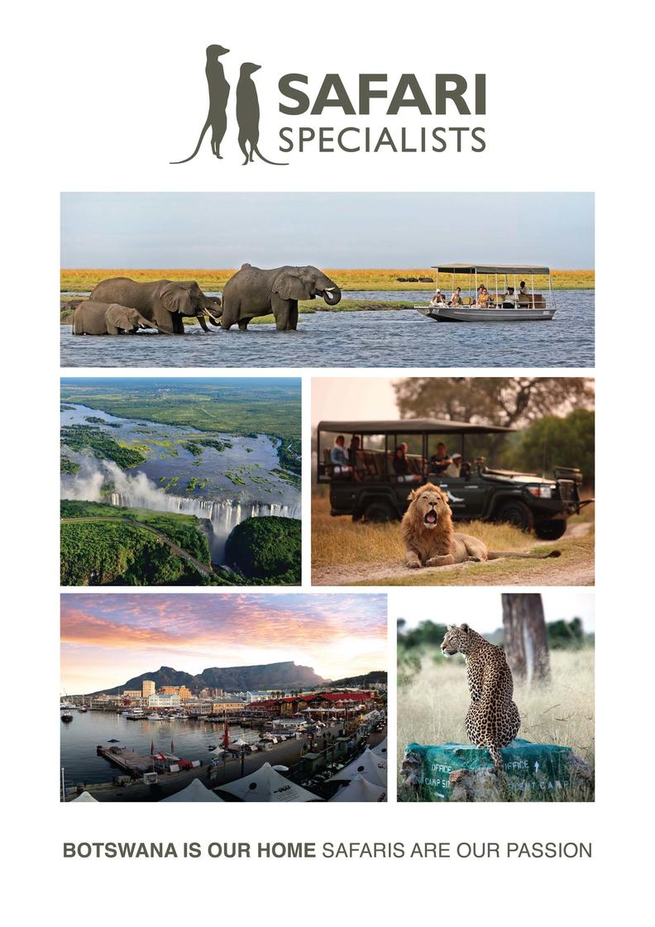

Safari Specialists Bots 50th Photo Competition

1st Prize – 8 night Safari
Makgadikgadi Pans National Park - Moremi Game Reserve - Chobe River Front - Victoria Falls, Zimbabwe
9 Days / 8 Nights
Date of Issue: 15 December 2016

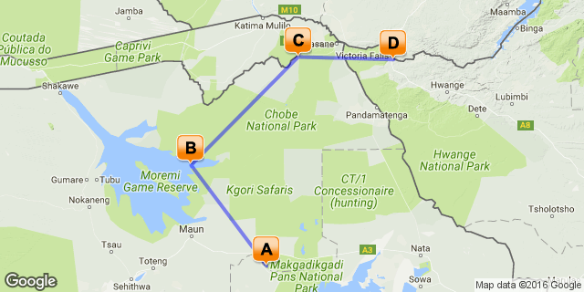

Click here to view your Digital Itinerary

Overview

Accommodation | Destination | Nights | Basis
Meno a Kwena Tented Camp | Makgadikgadi Pans National Park | 2 | FI
Okuti Camp | Moremi Game Reserve | 2 | FI
Chobe Elephant Camp | Chobe River Area | 2 | FI
The Elephant Camp | Victoria Falls, Zimbabwe | 2 | FI

Key
RO: Room only. B&B: Bed and breakfast. D, B&B: Dinner, bed and breakfast. FB: Dinner, bed, breakfast and lunch. FB+: Dinner, bed, breakfast, lunch and activities daily. FI: Fully inclusive.

Transport

Flight Information
Day | Airline | Details
03 | Mack Air | Air transfer Maun - Xakanaxa
05 | Mack Air | Air transfer Xakanaxa – Kasane

Transfers
Day | Company | Details
01 | Meno A Kwena | Maun Airport - Meno A Kwena (incl)
03 | Meno A Kwena | Meno A Kwena - Maun Airport (incl)
05 | Chobe Elephant Camp | Kasane to Chobe Elephant Camp
07 | Chobe Elephant Camp | Chobe Elephant Camp to Kasane
07 | Wild Horizons | Kasane to Victoria Falls Town
07 | The Elephant Camp | Victoria Falls Town to The Elephant Camp
09 | The Elephant Camp | The Elephant Camp to Victoria Falls Airport

Day 1-3: Meno a Kwena Tented Camp, Makgadikgadi Pans National Park

Upon arrival at Maun Airport you are met by a Safari Specialists representative. You are taken by a Meno-A-Kwena representative to the lodge where you are staying for 2 nights.

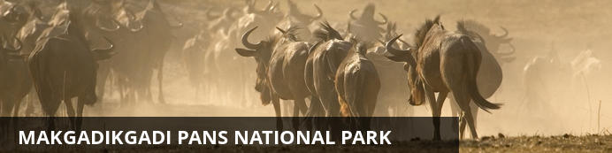
The Makgadikgadi National Park is where the Okavango Delta finally fades into desert. The Boteti River draws a line in the sand, separating the dry Makgadikgadi from the thirst lands of the Kalahari beyond. This is the ultimate last chance saloon for hundreds of zebras and wildebeest that crowd the water’s edge to quench a desert-drawn thirst.
The Boteti is the last finger of the Okavango Delta, reaching down to the Makgadikgadi Salt Pans. Years have passed without the river being fed a drop at all; becoming a long sandy riverbed with shrinking waterholes, where zebras jostle for space under high-flying sheets of dust. At other times, the Boteti swells up fat and full, spilling into saltpans hundreds of kilometers from its source before evaporating into thin air.
This is the place to watch plains game crashing through sharp acacia trees, gathering under lofty palms and lurking in the shade of the riverine woodland, keeping close to the water. When the Boteti River is full, big elephant bulls can often be found playing in the water and browsing in the reeds while the sun sets on the day.
Although the park’s eastern edges touch the Makgadikgadi saltpans, its unlikely you’ll see them during your stay. Where the saltpans are about landscapes, the Boteti is about a more traditional safari experience. Explore the banks by game drive, drift along the river by boat (when water levels allow), or wait for the wildlife to pass by from the sanctuary of a hide.
Once the rains arrive (October – November) the zebras and wildebeest abandon the Boteti, migrating to the saltpans and only returning in the winter (April – May). During the green season the Boteti’s banks become a quiet green landscape of technicolour sunsets and an explosion of birdlife.

Overnight: Meno a Kwena Tented Camp View iBrochure
Includes: meals, drinks, activities, park fees & laundry
Excludes: premium drinks and personal spending
Activities: game drives, bushmen cultural walks, boating (short cruises along the Boteti – water levels permitting) and game viewing from the floating hide
Meno A Kwena, meaning “teeth of the crocodile”, borders Makgadikgadi Pans National Park in close proximity to Nxai Pan National Park. The camp is situated on tribal land and has been built on a cliff edge overlooking the Boteti River.
This authentic safari camp is styled in the tradition of an East African tented camp. Meno A Kwena offers ten safari tents. The tents are simple yet stylishly furnished with comfortable bedding, a fan as well as gauze sliding doors and windows. Each tent has an en suite bathroom with a shower and a flush toilet. Each tent features a private sitting area with views over the Boteti River.
The main lodge has a dining area, bar and lounge with small library and features many interesting artefacts and photographs. Two covered seating areas at the edge of the escarpment provide guests with breath-taking views over the Boteti River. The river attracts many zebra and wildebeest herds during the dry season (June to Oct) offering excellent game viewing from the comfort of the camp. There is a small plunge pool, as well as a floating game viewing hide offering a close yet safe view across the river into the national park.
Activities at Meno A Kwena include guided nature walks with Bushmen (San), game drives into the Makgadikgadi National Park and game viewing from the floating hide on the Boteti river. For stays of 3 nights or longer, full day trips with a picnic lunch can be arranged to Makgadikgadi & Nxai Pan National Park. Camp will use discretion in deciding whether guests explore the Khumaga Area or Nxai Pan area depending on where game viewing is best. As a general guide, Khumaga is better during the dry season and Nxai Pan more likely to be explored during green season. Seasonal (July to October) overnight camping excursions to the salt pans are also available on request. Please note these activities must be pre-booked in advance and can’t be arranged on arrival in camp.
Meno A Kwena's informal atmosphere makes for a very relaxing stay after the hectic round of activities at many camps. Please note that due to the scheduled road transfer times, Meno A Kwena don't offer an activity on the afternoon of arrival. Guests are encouraged to take advantage of their unique location, relax and enjoy seasonal game viewing from the comfort of their own room or the hide.
PLEASE NOTE: Transfers leave Maun between 12:00 – 14:00 and leave the camp to depart for Maun between 09:00 – 10:30 to accommodate Air Botswana flights. Any guests arriving or departing later will need to pay an additional US$300.00 per transfer for the additional vehicle and guide.
Road Transfer Time from Maun: 2 hours
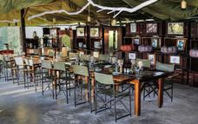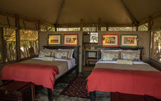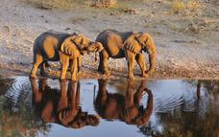

Day 3-5: Okuti Camp, Moremi Game Reserve

After breakfast, you are transferred back to Maun Airport for a light aircraft flight to Okuti Camp where you are staying for 2 nights on a fully inclusive basis.

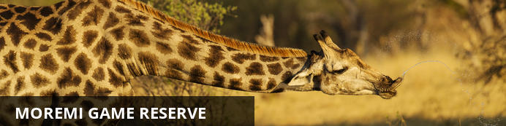
The Moremi Game Reserve is all about searching for big game; where the habitats are as diverse as the wildlife itself. Water-adapted antelopes and wary-eyed buffaloes spill out into floodplains, behind towering woodlands where leopards hide on the high branches. Dead trees cast silhouettes over elephant-filled savannas a stone’s throw from papyrus-fringed channels stretching out to the delta beyond.
When you arrive in the Moremi Game Reserve, it’s anyone’s guess what you’ll find lurking in the long grass. From wild dogs stalking waterbucks to long sunsets by a hippo-filled lagoon, the scenes will live on in memory long after the journey home.
Kick up sharp smelling clouds of dust on a morning drive, disturbing pockets of warm air in the reeds as you splash through water crossings in pursuit of a distant lion’s call. Pause by the edge of large lagoons, squinting to catch mischief making hyenas as they emerge from the trees to drink.
When you get sick of game drives, discover the channels by boat while Squacco herons fly alongside you into the wind. Watch a lazy sunset with the blue-cheeked bee eaters before returning to dry land for more hardcore bush exploration.
As Moremi Game Reserve is bound by national park rules, activities here are limited to game drives during hours of daylight with no off-roading, and boat cruises on the permanent channels.
While most of the reserve is open to the public, two private lodges sit in the Mombo Concession to the north of Chief’s Island, surrounded by the waters of the Okavango Delta. Boating isn’t possible here, instead the area offer the ultimate in dry-land game viewing. Hailed as Botswana’s predator capital, this exclusive corner is closed to outsiders and home to the big five, where the invitee list fills up years in advance.

Overnight: Okuti Camp View iBrochure
Includes: meals, local drinks, activities, park fees, laundry & return airstrip transfers
Excludes: premium drinks and personal spending
Activities: game drives and boating
Okuti is located alongside the Maunachira River, as it flows into the Xakanaxa Lagoon in the heart of the Okavango delta, within the Moremi Wildlife Reserve. Moremi is a park rich in wildlife and game viewing is consistent year round so it is ideal for the first time visitor to Botswana.
This luxury camp is designed in the African village style, accommodating a maximum of eighteen guests. Accommodation is in stylish and spacious units, each on raised platforms and containing en-suite bathrooms, featuring an outdoor shower with an incredible view. Camp Okuti is also extremely family friendly and boasts two family units with two rooms sharing a bathroom. Okuti Camp features an open dining area with stunning views across the lagoon, outdoor boma area and a swimming pool.
Activities offered are game drives in open safari vehicles exploring the diverse range of habitats within the reserve – from open floodplains to belts of mopane woodland. Guests can also venture out onto the open waters of the Okavango by motorboat, visiting the Xakanaxa Lagoon and beyond up to the seasonal heronry at Gadikwe. Moremi Game Reserve offers some of the most spectacular game viewing in Botswana and guests may encounter breeding herds of elephant, a hunting lioness or a sleeping pride of lion, grazing impalas, kudus and much more.
Airstrip Transfer Time: 30 minutes
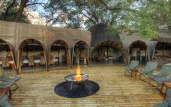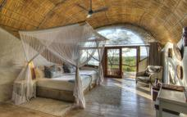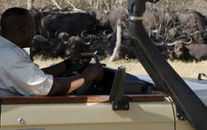

Day 5-7: Chobe Elephant Camp, Chobe River Front

After breakfast and morning activity you are transferred to Kasane town. A representative from Chobe Elephant Camp will take you to camp for your 2-night stay.

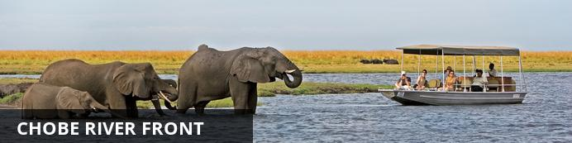
The Chobe Riverfront is an elephant mecca; home to the largest density of African elephants in the world. Travel here during winter and you’ll fast run out of fingers and toes while you count them drinking at the riverbanks and socialising out on the floodplains.
Thanks to its ease of access from Victoria Falls, the Chobe Riverfront is the busiest part of Botswana (though still a much quieter affair than most South or East African safaris). What Chobe lacks in solitude during the busier months, it more than makes up for with quality game viewing.
Chobe will leave you feeling tiny as giant elephant bulls stroll up next to your vehicle or snorkel alongside your boat. It will make you feel lost as hundreds of hippos and buffaloes crowd you out on the floodplains. It will put your heart in your throat as prides of lions stalk antelopes by the water’s edge, and it will leave you alone with your thoughts while the classic red sunsets melt over the river to a soundtrack of whistling fish eagles.
Chobe is not just a great introduction to Botswana. It also makes a rewarding repeat journey once you’ve ticked off the big stuff. It’s a place to search for the rare sable antelope, to spot that gem from the birders’ bucket list and to explore the remoter corners.
Where you stay in Chobe makes a huge difference to your safari experience. The most affordable options are at bigger hotels in a town setting where you’ll share your game drives with a few more vehicles. On the more exclusive end, stay in a wilder area in or around the park, listen to the sounds of the bush at night and get a head start on accessing the park for activities.

Overnight: Chobe Elephant Camp
Includes: meals, local drinks, activities, laundry and park fees.
Excludes: premium drinks and personal spending
Activities: game drives, boating (stays of 2 nights or longer) and cultural village visit
Located high on the edge of a rocky ridge overlooking the famous Chobe River is the newly developed Chobe Elephant Camp. This uniquely designed lodge has been built to take advantage of the incredible views overlooking the sweeping floodplains while offering a comfortable refuge from the harsh African conditions.
The lodge has been entirely constructed from sandbags, the thick sand-filled walls create a natural insulating barrier between the inhabitants and the harsh African climate and enhance the old farm-style feel of the camp. It houses ten rooms, one family room and can sleep 24 guests at a time.
With a variety of activities that include viewing the regions spectacular wildlife from open safari vehicles, by boat on the Chobe River or experiencing life in the village, a visit to Chobe Elephant Camp offers a wide range of experiences to our guests.
Chobe / Ngoma Gate
This property is located near the Ngoma Gate for entry to the Chobe Riverfront. Very few lodges are located on this end of the park and few people utilize this entry point, creating a more remote and exclusive experience than at the properties around Kasane. Although outside the park, this option is located in a bush setting where wildlife frequently passes through.
Airstrip/port transfer time: 50 minutes
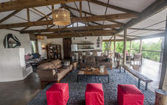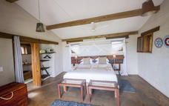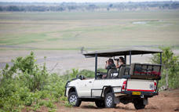

Day 7-9: The Elephant Camp, Victoria Falls, Zimbabwe

After breakfast and morning activity (flight time permitting) you are transferred to Kasane. You are met by Wild Horizons who will assist you with border formalities and take you to The Elephant camp in Victoria Falls for a 2-night stay.

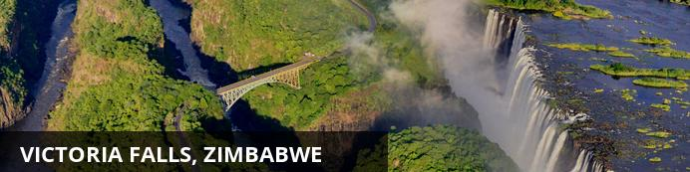
At Victoria Falls, the earth splits open and swallows one of Africa’s greatest rivers, the mighty Zambezi, creating the largest sheet of falling water on earth. As the water hits the narrow depths of the Batoka Gorge beneath, it blasts a cloud of mist skywards, lending the falls their local name ‘mosi-oa-tunya’ (the smoke that thunders). When the Zambezi is its fullest, the mist hangs a permanent raincloud above the falls, showering visitors on even the sunniest of days and visible for miles around.
Above the falls on the upper Zambezi, boats cruise the tranquil water at sunset while the distant spray catches the fading light downstream. Below the falls, the Batoka Gorge’s rocky walls funnel the lower Zambezi into a chain of world-class rapids, prime for white water rafting.
Aside from being a UNESCO world heritage site and a natural world wonder, Victoria Falls also forms a natural border between Zimbabwe and Zambia. The falls can be seen from both countries, and for the most part the same activities are offered on both sides, from helicopter scenic flights to village visits and souvenir shopping.
Whether your idea of getting away from it all is a relaxed high tea in colonial grandeur or a heart-stopping bungee jump off a bridge, Victoria Falls keeps both the faint of heart and the most insatiable of adrenalin junkies busy for days.
From Zambia, a side on view of the falls is on offer with views into the Batoka Gorge, as well as the possibility of perching yourself at the edge of the falls on the vertigo-inducing Livingstone Island.
From Zimbabwe, you’ll get a full-frontal view of three quarters of the falls’ 1.7km wide curtain of water from viewpoints and footpaths meandering through a rainforest kept hot and humid by the spray of the falls.

Overnight: The Elephant Camp View iBrochure
Includes: meals, selected drinks, airport transfers, 2 x transfers to Victoria Falls town per day & laundry
Excludes: activities (other than those specified) and premium drinks
Included Activities: elephant interaction, sundowners at Batoka Gorge, scheduled birding & nature walks, Additional Activities provided by Wild Horizons: Tour of Victoria Falls (Zimbabwe side, excluding entry fee) and Sundowner Cruise on the Zambezi (excluding river usage fee).
Any additional activities for own expense.
Situated on a private concession bounded by the Masuwe River and Zambezi gorges, The Elephant Camp has breathtaking views of the Victoria Falls’ spray and the spectacular gorges that separate Zimbabwe from Zambia.
The Elephant Camp is a luxury and intimate lodge under canvas within easy reach of Victoria Falls and all its attractions and activities, yet secluded in its own private game reserve so as to allow close-up encounters with wildlife.
The Elephant Camp offers exclusive accommodation with 12 suites in the main camp and an additional 4 suites at Elephant Camp West, as well as an on-site spa. All suites face the gorge and offer a private viewing deck, plunge pool, private lounge area, air-conditioning & fans, complimentary mini bar and tea and coffee stations. The en-suite facilities include a bath as well as an inside and outside shower.
The Elephant Camp offers close interaction with wildlife – in particular the elephants at the Wild Horizons Wildlife Sanctuary, which all guests will have the opportunity of meeting during their stay. Guests can enjoy lunch and drinks at the Lookout Cafe overlooking Batoka Gorge near the Victoria Falls (included in the rate when booked by prior arrangement). Sundowners at the Batoka Gorge and scheduled birding & nature walks on the concession are also included in the rate.
Spa treatments and all other activities on offer in Victoria Falls, as well as walks with Sylvester the cheetah are available at an additional cost and can be booked at the lodge.
Airport Transfer Time: 15 minutes
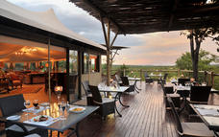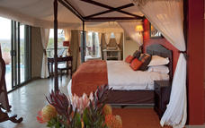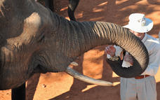

Day 9: Departure

After breakfast, you are transferred to Victoria Falls Airport for your onward connections.

Special Terms & Conditions Apply

This prize is subject to availability at the time of booking and is not redeemable for cash, cannot be transferred to any other person but the prize winner. Standard rates apply for accompanying travelers.
All flights into Maun and out of Victoria Falls, any required visas, all insurances are excluded.

Each prize giver has attached specific terms and conditions to their contribution. Guidelines as below. Please contact us to discuss details in full.

Meno A Kwena:
Includes all meals, selected drinks, activities, laundry, park fees and road transfer Maun – Meno A Kwena return.
Valid March – June 2017 and November 2017 – 5 January 2018. ** excludes Christmas/New Year and Easter

Camp Okuti:
Includes all meals, selected drinks, activities, laundry, park fees and transfers from Xakanaxa Airstrip return.
Valid March – June 2017 and November 2017 – 5 January 2018. ** excludes Christmas/New Year and Easter

Chobe Elephant Camp:
Includes all meals, selected drinks, activities, laundry, park fees and transfers from Kasane Airport return.
Valid January – June 2017 and November – December 2017 * optional upgrade to peak season available for additional cost on application.

The Elephant Camp:
Includes all meals, selected drinks, transfer from Kasane Airport to Camp and Camp to Victoria Falls Airport (or visa versa), twice daily return transfer to Victoria Falls town, Tour of Falls (excluding park fees) and Zambezi River Cruise (excluding park fees).
Valid January – 15 December 2017.

Mack Air Flights:
Amendments in route are possible to be arranged when booking the safari subject to any applicable further costs. On a seat rate basis, required to be booked minimum 72 hours in advance and are non- refundable.

General Travel Information

• Please take note of our Booking Terms & Conditions. It will be understood that these have been read and accepted by you on receipt of confirmation of the booking.
• For your safety and peace of mind, on confirmation of your booking, we strongly recommend that Travel Insurance is arranged to cover cancellation, curtailment, emergency evacuation, medical and repatriation expenses, damage/theft/loss of personal luggage, money and goods.
• Road and air transfers and activities are quoted on a seat basis (shared) unless otherwise requested or specified. Passengers may have various stops en-route to a destination. The transfer or charter company reserves the right to specify departure and arrival times. Private charters can be requested at an additional cost.
• Passengers weighing over 100kg should please advise us at the time of booking, as we may need to cost in an additional seat on internal flights for your safety and comfort.
• The costs are subject to change at any time due to fluctuations in fuel costs, taxes, levies, government regulations, rate of exchange and factors that are imposed upon us by our suppliers that are beyond or control.
• Please advise us of the ages of children (under 18) travelling, together with their date of birth, at the time of booking as not all lodges accept children and there may be restrictions or conditions which can affect pricing.
• We recommend that optional activities be booked in advance at time of confirmation to guarantee availability e.g. Elephant Back Safari in Victoria Falls
• Please allow a minimum 2-3 hours connection time in Johannesburg for international flights. It is important that you check that your flight tickets have been issued in your full names as per your passport.
• We require full payment for international and domestic scheduled flights at the time of confirmation e.g. Air Botswana JNB/MUB, Proflight LIV/LUS. We are not able to guarantee any flights before receipt of payment as seats are often held for a limited period before ticketing is required so this is a time sensitive issue. Air tickets are considered non refundable unless otherwise specified. Please confirm the details with your consultant at the time of booking.
Passports, Visas and Travel Documentation
Your passport must have at least 6 months validity before the expiry date and 6 empty pages (not including the endorsement pages). The onus is upon the guests to ensure that passports and visas are valid for the countries visited. Please note that certain visas can take up to 3 months to be processed so please consider this when booking.
If you are travelling with children through Southern Africa please be aware that you will be required to have certified copies of their unabridged birth certificates, and passports on hand. If you are not their legal parents, or if only one of you is travelling – you will need to have consent in the form of an affidavit giving you permission to travel with the child.
Inter-camp transfers
Due to the vast distances involved in travelling in the remote areas of Southern Africa - your itinerary may include road, boat and air transfers in small aircraft.
On shared air transfers, all the flight times between lodges are arranged a few days before the flights take place to avoid endless schedule changes. The lodge or camp where you are staying will be advised of your departure time the day before travel and will ensure that you are at the airstrip on time. Although every effort will be made to ensure that guests are transferred together in one vehicle / aircraft, this cannot be guaranteed, especially with larger groups. The aircraft used for inter-camp transfers vary in size from 3, 5, 7 and 12 seater aircraft. We recommend that guests susceptible to motion sickness take appropriate precautions due to flying conditions.
Weight & Luggage Restrictions
There are strict luggage restrictions in place on any itinerary, which includes light aircraft transfers for safety reasons. Luggage, including camera equipment and hand luggage, is restricted to 20 kg per person travelling on seat rates. Only soft bags will be accepted - no hard suitcases or bags with wheels can be transported, as they physically cannot fit into the aircraft.
The maximum dimensions of the soft bags that can be accommodated are as follows: 25cm/10 inches wide x 30cm/11 inches high and 62cm/24 inches long. Please keep in mind that the baggage compartments on the light aircraft are only 25cm high, so the pilots must have the ability to manipulate the bag into the compartment. Note that laundry can be done on a daily basis at most camps and lodges.
Should you arrive with excess baggage without prior warning, your baggage could be delayed, as we may have to fly the baggage into camp at a later stage at considerable extra cost to you. However, should you notify us in advance that your baggage will exceed the limit; we may be able to assist you with alternative arrangements e.g. storage or purchase of additional luggage allowance.
For bookings including flights within Zambia & Mozambique, please note luggage weight exceptions under destination information.
Lost Luggage
Lost luggage on international flights is a common problem facing travellers today. We suggest that you pack a small bag with your essentials, including any life sustaining medication, which can be carried with you as hand luggage. If travelling as a couple or family we suggest that you split your clothing between bags so that if one bag gets lost, you will have basic items on hand to see you through the first couple of days while we try and recover your lost baggage.
Please note that whilst we try our utmost to locate and re-unite you with your bags, that there may be charges involved in getting your bags to remote areas, which would be for your cost. Please remember to report the lost luggage to the airline as soon as you make the discovery - the airline will issue you with a Baggage Claim Form, which you will need in order for us to trace the bag.
Health and Dietary
Please note that you are travelling to a Malaria-risk area. Please consult your doctor for medical advice prior to travel.
Although usually safe to drink, we do not recommend that you drink the tap water. Filtered water is available at the camps and lodges.
The camps are isolated and generally have limited power supply and access to supplies. Please notify us in advance of any special dietary requirements, medical conditions and medical equipment you may need with you. Please carry critical medication in your hand luggage.
Yellow Fever Certificates - are only required if you have travelled to a Yellow Fever area as designated by the World Health Organisation. Please check with your Travel Clinic or doctor well in advance of your departure date.
General Travel Information
• There is no or limited electricity and cell phone coverage in the camps and lodges excluding major towns and cities. All camps do make provision for charging cameras and electronic devices.
• Please ensure that you do not pack any valuables, cameras, cash, laptops in your checked in luggage – these should be kept on your person at all times.
• Please notify us immediately of any changes to flight arrival and departure details as this affects onward transfer arrangements.
• Please note that most camps & lodges in Botswana do not have double beds. Twin beds are pushed together to make up a double room.
• Although every effort is made to adhere to schedules the company reserves the right and in fact is obliged to occasionally change routes and camps on safaris as dictated by changing conditions or unforeseen circumstances.
• By confirmation of the booking, you acknowledge that you have been made aware and accept that the tour carries inherent risks, and that you voluntarily assume all risks which are associated with the tour. You will be required to sign indemnities at the various camps, lodges and service providers, and abide by their operators code of conduct in order to ensure your safety.
• If you have any cause for complaint while travelling, you should immediately bring it to the attention of the camp manager and / or our Maun office that will attempt to resolve the situation immediately.
• Do not remove any animal artefacts, flora or fauna from any of the areas you visit, as there are strict international regulations on the export of such items.
Please refer to the Safari Information for further details on preparing for your safari.
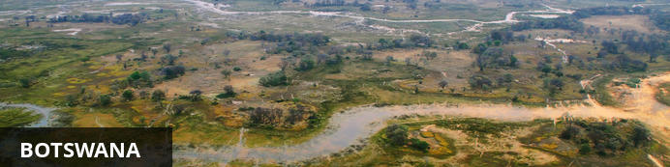
Visa
Some visitors need to apply for visas before arrival please check with your Embassy.
For more information on visas please visit the following address:
Botswana Government - Visa Requirements
Currency
The currency of Botswana is the Pula (BWP). US$ Dollar notes (2007 Series onwards), and Visa and MasterCard are accepted.
Internal Flights and Transfers
Due to the remote areas the camps and lodges are based in, transfers between camps may take place by boat, mekoro, game drive vehicle or light aircraft.
Flight times around Botswana | Approximate flying times
Flight duration times (as listed below), are to be used as an average guideline. They are based on actual flying time, and passengers may have various stops en-route to a destination affecting the total travel time. Your pilot will brief you of your flight route and duration during the safety briefing.
Maun - Delta: 15 to 30 minutes
Delta – Delta: 10 to 20 minutes
Delta - Linyanti: 30 to 40 minutes
Maun – Linyanti: 50 to 60 minutes
Linyanti - Kasane: 40 to 60 minutes
Maun/Delta - Kasane: 60 to 80 minutes
Maun - Makgadikgadi/Desert: 40 to 60 minutes
Departure Taxes
Departure taxes are included in ticket prices.
Weight & Luggage Restrictions
See Booking Information

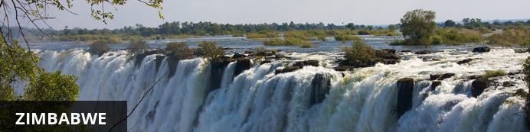
Currency
The currency of Zimbabwe is the American Dollar (US$). US$ Dollar notes (2007 Series onwards), and Visa and MasterCard are accepted.
Visa
Fees for Visitors to Zimbabwe who are eligible to receive their visa on entry
Europe and USA: U$D 30.00 for single entry/ U$D 45.00 for double entry.
UK & Ireland: U$D 55.00 for single entry/ U$D 70.00 for double entry.
Canada: U$D 75.00 for single entry/ double entry to be obtained from local embassy prior to travel
Some visitors need to apply for visas before arrival - please check with your Embassy, Zimbabwe Government Visa Requirements
Kaza Univisa – Zimbabwe and Zambia
The Univisa was suspended asof the 31 Dec 2015. Please contact your Travel Agent for updated information.
Internal Flights and Transfers
Due to the remote areas the camps and lodges are based in, transfers between camps may take place by boat, train, game drive vehicle or light aircraft.
Departure Taxes
International departure taxes are included in the scheduled flight rates. However light aircraft transfers from Victoria Falls Airport to Livingstone or Kasane require an International Departure tax of US$35 per person & AIDF Levy of $15 = $50 per person to be paid in cash.
Domestic departure taxes are payable in cash at the airport, for any flights departing internally from any registered, manned airport. These include Harare, Bulawayo, Kariba, Hwange and Victoria Falls Airport. The amount is US$10 departure tax + US$5 AIDF Levy = US$15 per person. We recommend small denominations for easier and quicker transactions as change is not always available. Traveller’s cheques and credit cards are NOT accepted.
Weight & Luggage Restrictions
See Booking Information

